**Database Design Coursework Template**

Student Name: Daniel Tian

**Scenario Topic Name**: Museum database

**Scenario** (100 words maximum):

A history museum database that saves information about staff in the staff entity, which is recursive since a manager can manage multiple staff members. The staff entity generalises into specific job roles, such as cleaner, receptionist, historian and security. These are divided with an XOR since you cannot have multiple job roles, with each having their own role specific attributes. Assignment is the action entity that links together staff with, location, display pieces, replicas and era entities. This entity manages where staff members work, what they work on and the shift time.

**Example queries** (Minimum 5 – list, who, which, how many, most, fewest etc. - check that your models have the attributes needed to answer the queries)

Where is this staff member currently working?

What is the email address of this staff member?

Where is this display piece?

When does this staff members shift start?

What ever is this display piece from?

What is the office number of this historian?

What is the password for my account? (receptionist POV)

What building is this display piece in?

What can this receptionist access?

What is this staff members job title?

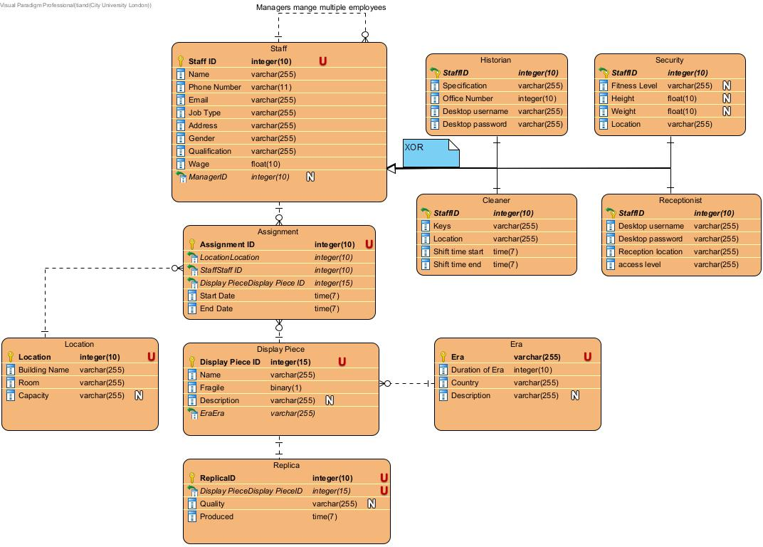**Entity Relationship Model** (insert a jpg image of your model exported from Visual Paradigm in the space below).

**Relational Model Tables**

* Copy and paste the table below for as many relational tables as you need
* Replace the placeholder names (table-name1, attribute-name5 etc) with the table and attribute names you derived from your ER model
* List primary key attributes first
* Add new rows to the tables (in the correct place) as needed
* Delete any unnecessary rows (attribute rows and foreign key rows if not used)
* Primary keys are to be specified in the format PRIMARY KEY (attribute-name1, attribute-name2, etc)
* Foreign keys are to be specified in the format ‘FOREIGN KEY (attribute-name) REFERENCES table-name (attribute-name)

|  |  |
| --- | --- |
| **Relational table specification** | **Marker’s corrections (Do not write in this column)** |
| **Table name:** table-name1 |  |
| **Attributes** |  |
| attribute-name1 |  |
| attribute-name2 |  |
| attribute-name3 |  |
| attribute-name4 |  |
| etc |  |
| **PRIMARY KEY** (attribute-name1, attribute-name2, etc) |  |
| **FOREIGN KEY** (attribute-name3) REFERENCES table-name2 (attribute-name67) |  |
| **FOREIGN KEY** (attribute-name4) REFERENCES table-name5 (attribute-name129) |  |
| etc |  |

Insert additional tables here……..

|  |  |
| --- | --- |
| **Relational table specification** | **Marker’s corrections (Do not write in this column)** |
| **Table name:** Staff |  |
| **Attributes** |  |
| StaffID |  |
| Name |  |
| Phone Number |  |
| Email |  |
| Job Type |  |
| Address |  |
| Gender |  |
| Qualification |  |
| Wage |  |
| **PRIMARY KEY** (StaffID) |  |
| **RECURSIVE RELATIONSHIP** ID > ManagerID |  |
| **SUBCLASSES** (Historian, Security, Cleaner, Receptionist) |  |

|  |  |
| --- | --- |
| **Relational table specification** | **Marker’s corrections (Do not write in this column)** |
| **Table name:** Historian |  |
| **Attributes** |  |
| All attributes from Staff |  |
| StaffID |  |
| Specification |  |
| Office Number |  |
| Desktop username |  |
| Desktop password |  |
| **PRIMARY KEY** (StaffID) |  |
| **SUPER CLASSS** (Staff) |  |

|  |  |
| --- | --- |
| **Relational table specification** | **Marker’s corrections (Do not write in this column)** |
| **Table name:** Security |  |
| **Attributes** |  |
| All attributes from Staff |  |
| StaffID |  |
| Fitness Level |  |
| Height |  |
| Weight |  |
| Location |  |
| **PRIMARY KEY** (StaffID) |  |
| **SUPER CLASSS** (Staff) |  |

|  |  |
| --- | --- |
| **Relational table specification** | **Marker’s corrections (Do not write in this column)** |
| **Table name:** Cleaner |  |
| **Attributes** |  |
| All attributes from Staff |  |
| StaffID |  |
| Keys |  |
| Location |  |
| Shift time start |  |
| Shift time end |  |
| **PRIMARY KEY** (StaffID) |  |
| **SUPER CLASSS** (Staff) |  |

|  |  |
| --- | --- |
| **Relational table specification** | **Marker’s corrections (Do not write in this column)** |
| **Table name:** Receptionist |  |
| **Attributes** |  |
| All attributes from Staff |  |
| StaffID |  |
| Desktop username |  |
| Desktop password |  |
| Receptionist location |  |
| Access level |  |
| **PRIMARY KEY** (StaffID) |  |
| **SUPER CLASSS** (Staff) |  |

|  |  |
| --- | --- |
| **Relational table specification** | **Marker’s corrections (Do not write in this column)** |
| **Table name:** Assignment |  |
| **Attributes** |  |
| Assignment ID |  |
| Location |  |
| Staff ID |  |
| Display Piece ID |  |
| Start Date |  |
| End Date |  |
| **PRIMARY KEY** (Assignment ID) |  |
| **FOREIGN KEY** (Location) REFERENCES Location (Location) |  |
| **FOREIGN KEY** (StaffID) REFERENCES Staff (StaffID) |  |
| **FOREIGN KEY** (Display Piece ID) REFERENCES Display Piece (Display Piece ID) |  |

|  |  |
| --- | --- |
| **Relational table specification** | **Marker’s corrections (Do not write in this column)** |
| **Table name:** Location |  |
| **Attributes** |  |
| Location |  |
| Building Name |  |
| Room |  |
| Capacity |  |
| **PRIMARY KEY** (Location) |  |

|  |  |
| --- | --- |
| **Relational table specification** | **Marker’s corrections (Do not write in this column)** |
| **Table name:** Display Piece |  |
| **Attributes** |  |
| Display Piece ID |  |
| Name |  |
| Fragile |  |
| Description |  |
| EraEra |  |
| **PRIMARY KEY** (Display Piece ID) |  |
| **FOREIGN KEY** (Era) REFERENCES Era (Era) |  |

|  |  |
| --- | --- |
| **Relational table specification** | **Marker’s corrections (Do not write in this column)** |
| **Table name:** Replica |  |
| **Attributes** |  |
| ReplicaID |  |
| Display PieceID |  |
| Quality |  |
| Produced |  |
| **PRIMARY KEY** (ID) |  |
| **FOREIGN KEY** (Display Piece ID) REFERENCES Display Piece (Display Piece ID) |  |

|  |  |
| --- | --- |
| **Relational table specification** | **Marker’s corrections (Do not write in this column)** |
| **Table name:** Era |  |
| **Attributes** |  |
| Era |  |
| Duration of Era |  |
| country |  |
| Description |  |
| **PRIMARY KEY** (Era) |  |

**Marker’s Comments** (Do not write in this section)

**Important:** Please note that marker’s corrections to your relational tables are there to help you construct a working database for the second coursework. They are not the determinant of your mark. For more information on how your work is assessed see the coursework specification and grade related criteria.

**Coursework Mark** (100 marks available):